Connecting to a MySQL server.

Click to Add a New MySQL Connection

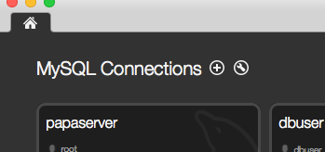

When window opens add in following details:

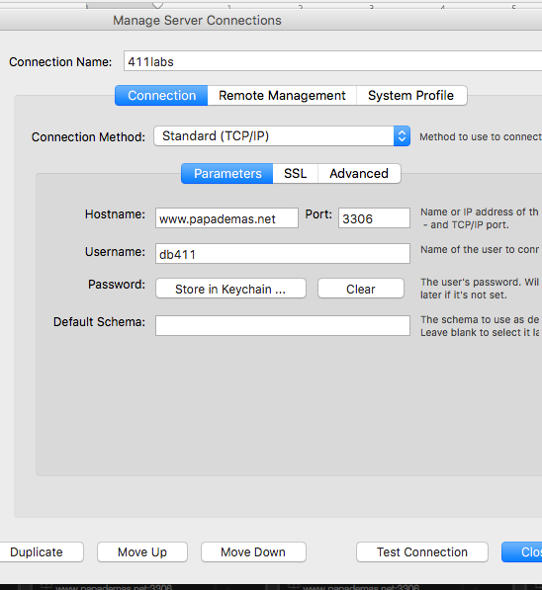

Click on Store in Keychain … to enter your Password in- enter as 411 for this instance.

Click Test Connection to see if it works. Click OK to finish. Voila!